ECKEL HELPS SKULLCANDY BOOST INNOVATION & QUALITY
AT NEW HEADQUARTERS
Anechoic Test Chamber Strengthens Brand’s R&D Capabilities

FOR IMMEDIATE RELEASE: August 1, 2017

Cambridge, MA—Headquartered in Park City, Utah, Skullcandy has grown into a prominent global brand known for its lifestyle high-performance audio products. The modern and spirited company continues to grow, expanding its product lines together with its R&D capabilities, all the while remaining true to its stated goal: “innovate to solve real problems and democratize amazing audio experiences with quality and style.”

With great innovation comes great responsibility, and Skullcandy is passionate about achieving the highest audio standards with each step it takes in product development. That’s why its leadership chose Eckel Noise Control Technologies (Eckel) of Cambridge, MA to design and produce an anechoic chamber for product and component testing in the R&D area of its new headquarters. Skullcandy Director of Global Product Management Matt Windt said he went directly to Eckel because of the company’s reputation for performance and value.

“From our first conversation, it was obvious that Matt was very knowledgeable about our anechoic chambers, which made my job that much easier,” Eckel Vice President Jeff Morse said. “I met with Matt to discuss Skullcandy’s needs and our capabilities. When I showed him the video of our world record-breaking Microsoft chamber, that seemed to seal the deal.”

“It was great to have Jeff out to Park City to talk through our vision. He was able to quickly assess our needs and get the chamber specified within our performance and budget requirements,” said Windt.

On February 20, 2017, Eckel’s installer—Viking Enterprises, led by Senior Superintendent David Engdall—began assembling the anechoic chamber at Skullcandy’s new headquarters in Park City. The process began with building the “host structure” or “box” that would contain the chamber and progressed through multiple steps, including creating the sub-floor panel system, an isolated sub-floor steel assembly and a spring-isolated stainless steel aircraft cable floor. The Viking team also assembled and erected the panels for the chamber walls and ceiling, and installed Eckel’s anechoic wedges on the sub-floor, wall and ceiling panels. The panels themselves have integrated track systems onto which Eckel’s anechoic wedges are mounted.

Engdall and his team made sure all chamber components were seamlessly incorporated into the Eckel design, which included meeting seismic requirements for its geographic location. Then, in a conversation between Engdall and Windt about chamber lighting, they struck upon the final—and one-of-a-kind—touch. Engdall envisioned creating a multi-color underfloor LED lighting system (see video).

“I could totally see where David was going with his vision, and our brand needs to add our personal touch to everything, so this idea was perfect,” said Windt. “The LEDs are bright enough to allow for working in the chamber without the main lights on.”

On March 23, with the LEDs in place, Skullcandy had its finished anechoic chamber. Externally, it measures 22 ft. by 20 ft. and 17 ft. high. Internally (wedge-tip to wedge-tip), it’s 15 ft. 8 in. by 13 ft. 8 in. and 10 ft. 4 in. high. Skullcandy personnel can access the chamber through a 4 ft. by 7 ft. combination wedge and sound door. Tests on April 15 confirmed the chamber met the ISO 3745 standard and achieved 17dBA ambient sound and a 100-Hz frequency cutoff.

(more)

The chamber will be used for testing frequency response, total harmonic distortion and intelligibility of Skullcandy components and products. The main focus is to have a consistent environment to do development testing and acoustic tuning, ranging from communication microphone development to earbud and headphone tuning to speaker tuning and driver development. The chamber’s uses are likely to grow and change with the company. Windt said, “Our products are constantly evolving; this is one of the strengths of our brand. We are constantly reinventing what we consider ‘best’ and pushing that throughout our entire product line.”

Eckel is proud of the finished product, and Skullcandy is thoroughly pleased. “Our brand is committed to obtaining the resources required to exceed customer expectations and be best-in-class,” Windt said. “Our anechoic chamber is a massive step forward on improving all acoustic aspects of our products, and I believe it’s a superior chamber because we worked with Eckel.”

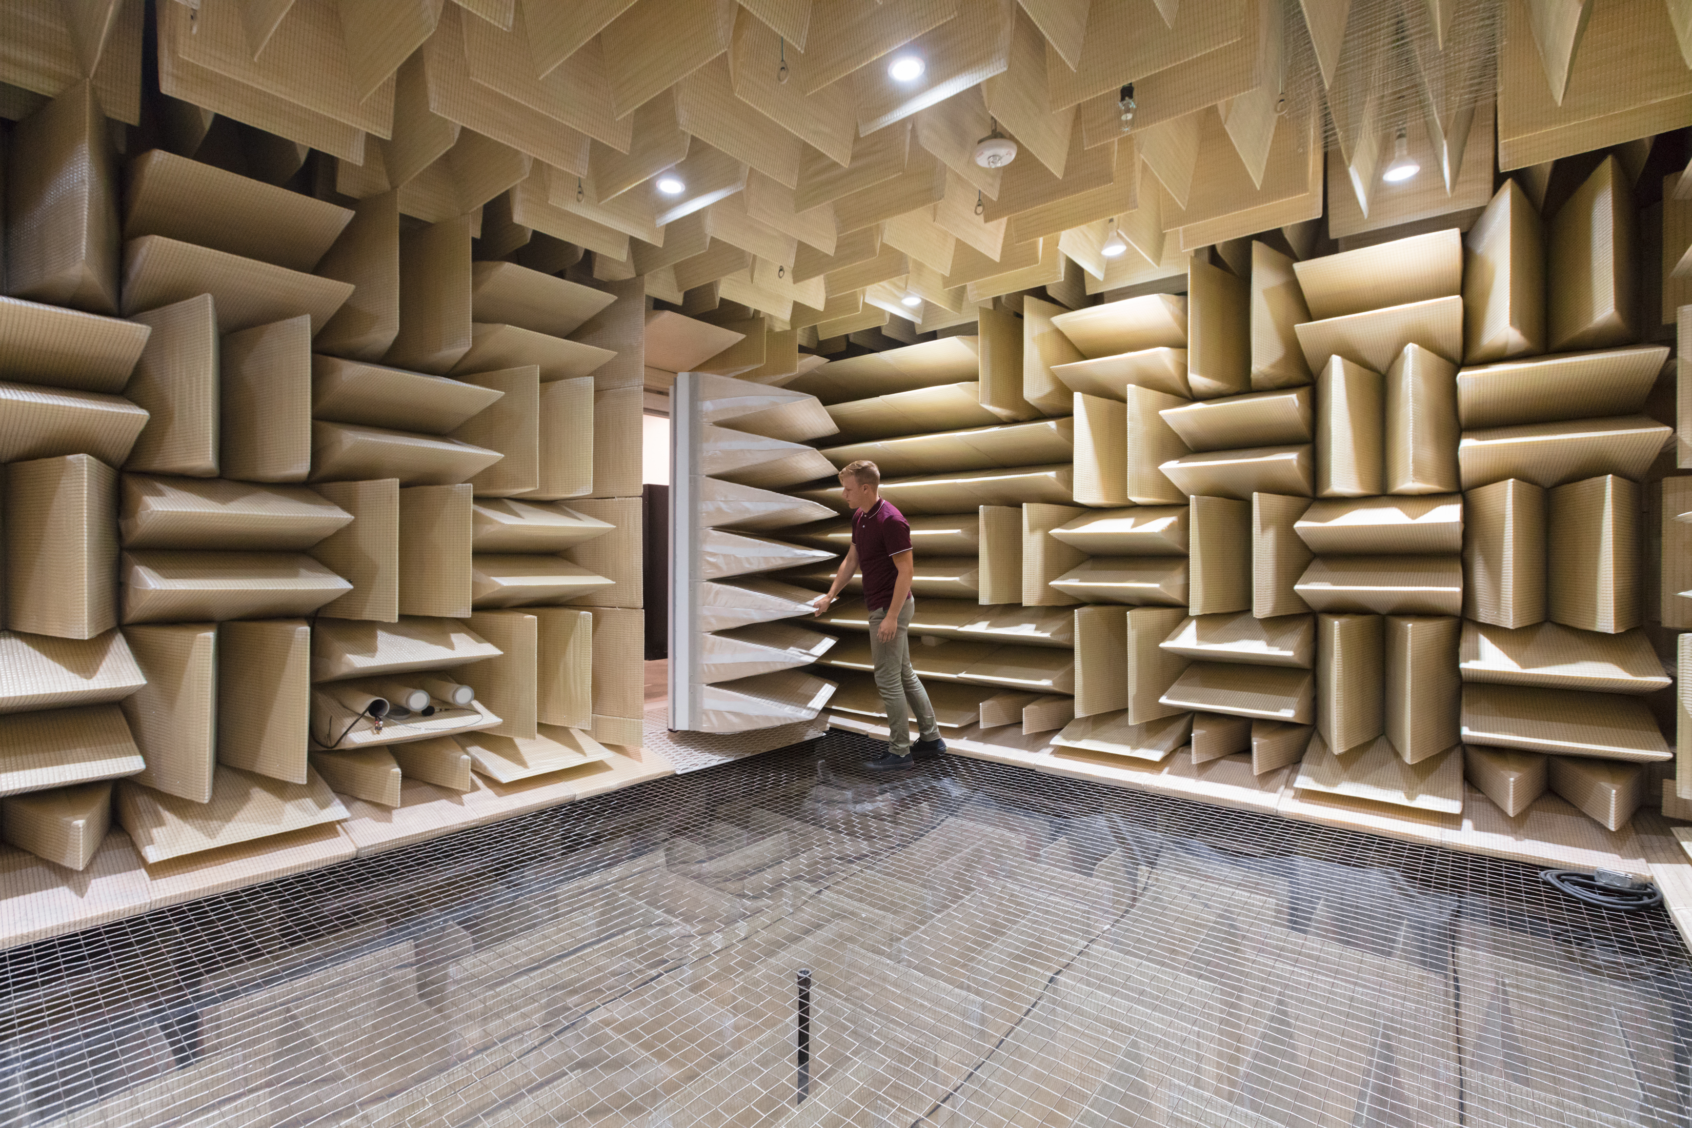
Eckel Anechoic Chamber at Skullcandy HQ

Skullcandy’s New Headquarters; Park City, Utah

Contact for additional information, hi-res images and interviews:
Sue Minichiello, Director of PR Services, SpaceAge Media Consultants
sue@spaceage-media.com 617-782-5995

About Eckel Noise Control Technologies
With expertise in creating optimal sound environments, Eckel Noise Control Technologies has been at the forefront of acoustic analysis and design for more than 60 years. Headquartered in Cambridge, MA, Eckel helped to create the world’s first Anechoic Chamber at Harvard University. Since then, the company has pioneered chamber design for use in product testing—from cell phones to cars to jet engines—helping engineers and manufacturers achieve exceptional quality standards. Building on the science behind its chambers, Eckel’s Audiometric Rooms create the ideal controlled environment for hearing testing and other sound isolation applications; while its Acoustic Panel Systems provide precise control of reverberation and background noise in any setting—from auditoriums and gyms to concert halls and industrial facilities. No matter the acoustic challenge, Eckel has a sound solution. Learn more at www.eckelusa.com.

About Skullcandy®
Founded at the intersection of music, sports, technology and creative culture, Skullcandy creates world-class audio and gaming products for the risk-takers, innovators and pioneers who inspire us all to live life at full volume. From new innovations in the science of sound, to collaborations with up-and-coming musicians and athletes, Skullcandy lives by its mission to inspire life at full volume through forward-thinking technologies and ideas, and leading-edge design and materialization. Skullcandy designs, markets and distributes audio and gaming headphones, and other accessory-related products under the Skullcandy and 2XL brands. The company’s products are sold and distributed through a variety of channels around the world from its global locations in Park City, Tokyo, Zurich, Vancouver and Mexico City, as well as through partners in some of the most important cultural and sports hubs in the world. The company’s website can be found at www.skullcandy.com.

###

